HAROLD ‘JUKEBOX’ ROBINSON

Harold "Jukebox" Robinson was born in Tuskegee, AL. Since 15 years old, Harold has been a musician. Robinson was a member of ‘The Corvettes’ which was under the direction of the late Bassist, Richard Pinkard. The Corvettes opened for Peggy Scott and Jo Jo Benson, along with Tyrone Davis. Robinson played for The Duponts, a band in which Tom Joyner was a member. Robinson then joined The Vibrations. His ex-wife also sang and she did sing background for The Commodores. So Robinson even married into music. The couple joined the US Navy Band while stationed in Pearl Harbor, HI. Harold went on to earn a B.A. in Music from Alabama State University which is near Robinson’s hometown Tuskegee. Alabama State University is located in Montgomery, AL. Robinson went on to earn a Masters in Music from Coral Gables’ University of Miami. Robinson returned to Alabama and worked as Assistant Band Director under Danny Davis who helped as the Percussion Specialist. Robinson still continued his passion for music and served as the Elementary School Band Director for all 5 elementary schools in the system. He also became Assistant Band Director of the high-stepping Jess Lanier Purple Tiger Band. Robinson served in music for many schools in Alabama including: Robert E. Lee Elementary, Powell Elementary and Kirby Middle.

A man of many musician hats, Robinson has paid his dues in the music circuit. He has performed with greats such as Stevie Wonder and Howard Hewett. Robert is currently performing R&B and Old School Music in a One Man Band. He sings vocals while playing the piano, working the drum machine and he plays bass. Robinson has music on Spotify and CD Baby. He has continued being an excellent musician in the Performing Arts.
https://rateyourmusic.com/artist/harold_jukebox_robinson

Robinson's CD Baby Link

Robinson's Spotify Link
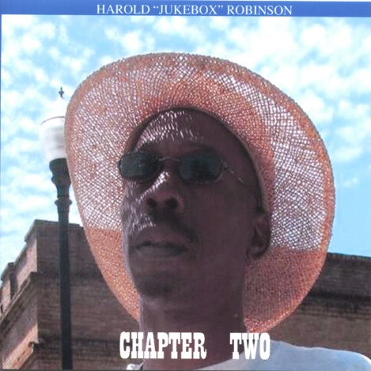

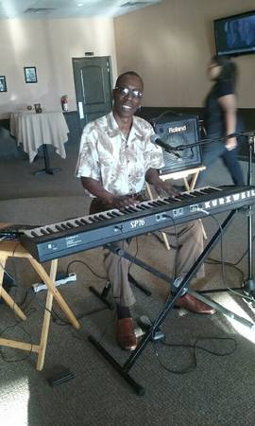

Jason Brye’s Critique of Harold Robinson’s Music

I heard samples of Harold's funky music on CD Baby. I was drawn to listen to the song 'Tuskegee' since I've taken part in Homecoming celebrations at the famous Alabama University. But I loved the concept. The funk moved me. And I love his style of instrumentals. He has a grown vibe and classic voice. The song reminded me of the great legacy of the 'Tuskegee Airman.' So Harold is a conscious artist who knows history and integrity. Tuskegee is a proud school and many of its students possess profoundly unique qualities. So it was great to make a song out of the town.
After listening to a snippet of 'Tuskegee,' I was then compelled to listen to Harold's song 'Stand' and I felt empowered and listening to the song called for inspiration. The distinction and illustriousness that I obtained while listening to 'Stand' made me feel a bit emotional. With so much going on in an ever changing world, this song is definitely warranted.

I admired Harold's positive initiative in regards to this cleverly mastered jam. I wanted to be great and do something powerful. It made me care more, though I've always cared. But songs are supposed to illuminate us and move us with greatness. And 'Stand' did that for me. The artist put a lot of thought in his music. I also love how he could take a simple concept and make a full song out of it. That takes much skill and unique talent. I would have to hear more to get into a consistent groove, but so far I heard eccentricity and unconventionality. He is an artist who takes risk which means he 'stands' out from a crowd of numerous musicians who are out in the world making music. BRILLIANCE! (Review given by Jason Brye of JasonBrye.com)

